# Graphing Parabolas with Vertices at the Origin

A **parabola** is formed if the plane is parallel to the edge of the cone, as shown below.

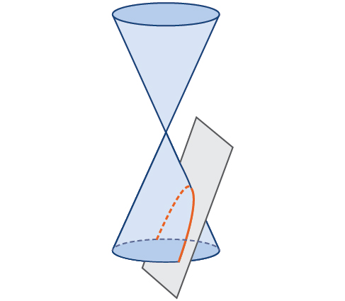

Like the ellipse and hyperbola, the parabola can also be defined by a set of points in the coordinate plane. A parabola is the set of all points $(x,y)$ in a plane that are the same distance from a fixed line, called the **directrix**, and a fixed point (the **focus**) not on the directrix. The **axis of symmetry** passes through the focus and vertex and is perpendicular to the directrix. The vertex is the midpoint between the directrix and the focus.

The line segment that passes through the focus and is parallel to the directrix is called the latus rectum. The endpoints of the latus rectum lie on the curve. By definition, the distance $d$ from the focus to any point $P$ on the parabola is equal to the distance from $P$ to the directrix.

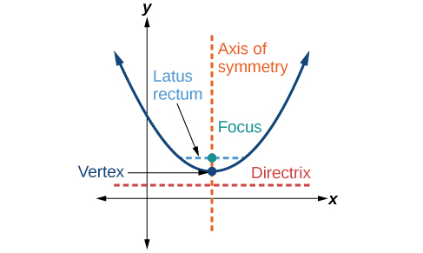

**Standard Forms of Parabolas with Vertex $(0,0)$**

The table and figures below summarize the standard features of parabolas with a vertex at the origin.

|  |  |  |
| --- | --- | --- |
| Axis of Symmetry | $x$-axis | $y$-axis |
| Equation | $$y^{2}=4px$$ | $$x^{2}=4py$$ |
| Focus | $$(p,0)$$ | $$(0,p)$$ |
| Directrix | $$x=-p$$ | $$y=-p$$ |
| Endpoints of Latus Rectum | $$(p,±2p)$$ | $$(±2p,p)$$ |

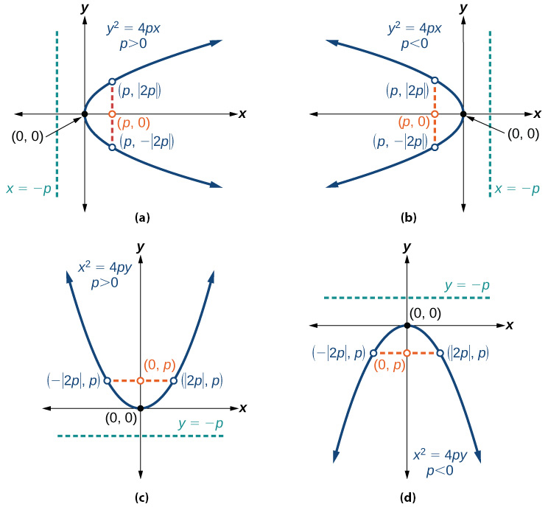

The key features of a parabola are its vertex, axis of symmetry, focus, directrix, and latus rectum. When given a standard equation for a parabola centered at the origin, we can easily identify the key features to graph the parabola.

**Given a standard form equation for a parabola centered at $(0,0)$, sketch the graph.**

1) Determine which of the standard forms applies to the given equation: or .

2) Use the standard form identified in Step 1 to determine the axis of symmetry, focus, equation of the directrix, and endpoints of the latus rectum.

a. If the equation is in the form $y^{2}=4px$, then

• The axis of symmetry is the $x$-axis, $y=0$

• Set $4p$ equal to the coefficient of $x$ in the given equation to solve for $p$. If $p>0$, the parabola opens right. If $p<0$, the parabola opens left.

• Use $p$ to find the coordinates of the focus, $(p,0)$

• Use $p$ to find the equation of the directrix, $x=-p$

• Use $p$ to find the endpoints of the latus rectum, $(p, ±2p)$. Alternately, substitute $x=p$ into original equation.

b. If the equation is in the form $x^{2}=4py$, then

• The axis of symmetry is the $y$-axis, $x=0$

• Set $4p$ equal to the coefficient of $y$ in the given equation to solve for $p$. If $p>0$, the parabola opens up. If $p<0$, the parabola opens down.

• Use $p$ to find the coordinates of the focus, $(0,p)$

• Use $p$ to find the equation of the directrix, $y=-p$

• Use $p$ to find the endpoints of the latus rectum, .

3) Plot the focus, directrix, and latus rectum, and draw a smooth curve to form the parabola.

Examples

1. Graph $y^{2}=24x$. Identify and label the focus, directrix, and endpoints of the latus rectum.

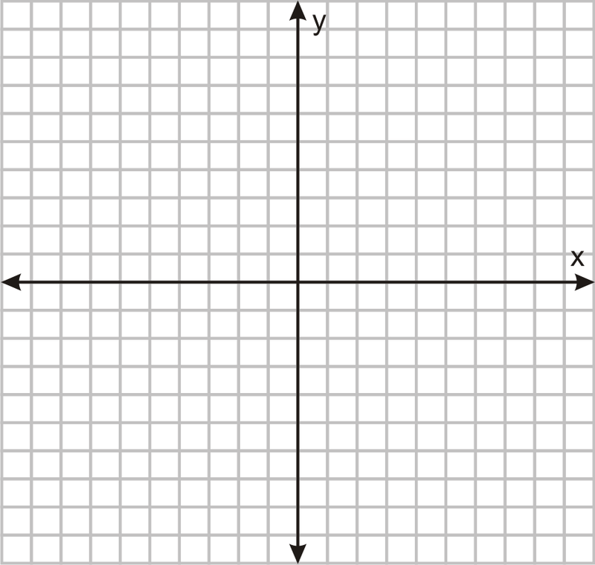

1. Graph $x^{2}=-6y$. Identify and label the focus, directrix, and endpoints of the latus rectum.



1. Determine the equation for the parabola from its graph.

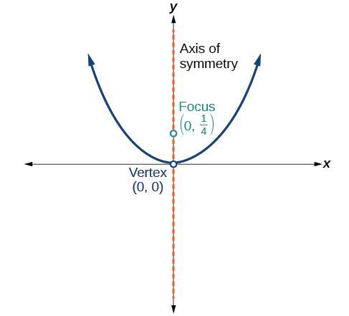

# Writing Equations of Parabolas in Standard Form

**Given its focus and directrix, write the equation for a parabola in standard form.**

1) Determine whether the axis of symmetry is the $x$- or $y$-axis.

a. If the given coordinates of the focus have the form $(p,0)$, then the axis of symmetry is the $x$-axis. Use the standard form $y^{2}=4px$.

b. If the given coordinates of the focus have the form $(0,p)$, then the axis of symmetry is the $y$-axis. Use the standard form .

2) Multiply .

3) Substitute the value from Step 2 into the equation determined in Step 1.

Example

What is the equation for the parabola with focus $\left(-\frac{1}{2},0\right)$ and directrix $x=\frac{1}{2}$?

# Graphing Parabolas with Vertices Not at the Origin

Like other graphs we’ve worked with, the graph of a parabola can be translated.

**Standard Forms of Parabolas with Vertex $(h,k)$**

The table and figures below summarize the standard features of parabolas with a vertex at a point $(h,k)$.

|  |  |  |
| --- | --- | --- |
| Axis of Symmetry | $$y=k$$ | $$x=h$$ |
| Equation | $${\left(y-k\right)}^{2}=4p\left(x-h\right)$$ | $${\left(x-h\right)}^{2}=4p\left(y-k\right)$$ |
| Focus | $$(h+p,k)$$ | $$(h,k+p)$$ |
| Directrix | $$x=h-p$$ | $$y=k-p$$ |
| Endpoints of Latus Rectum | $$(h+p,k±2p)$$ | $$(h±2p,k+p)$$ |

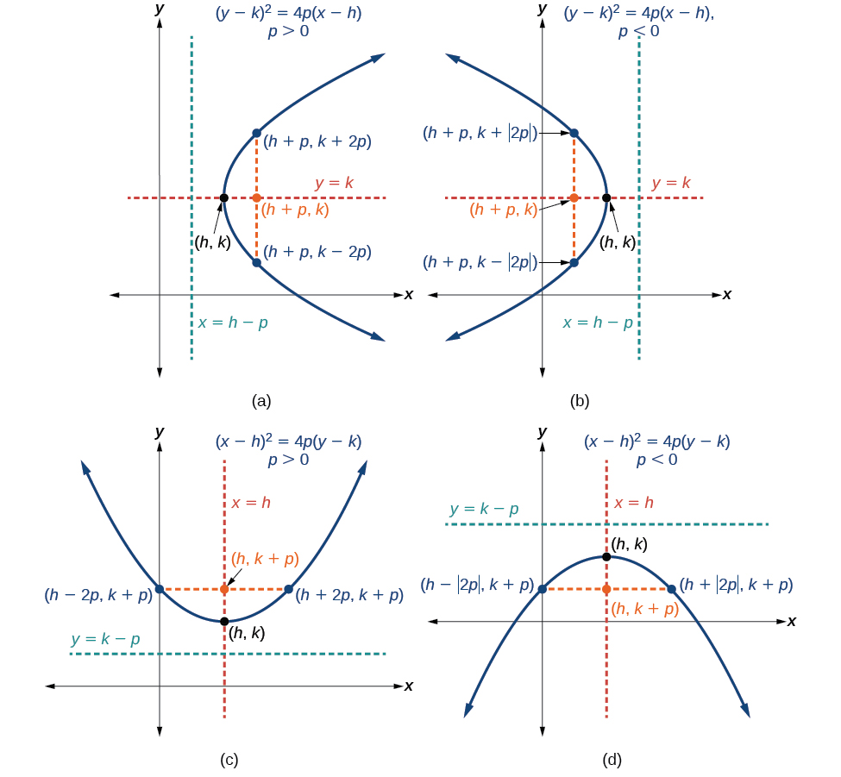

**Given a standard form equation for a parabola centered at $(h,k)$, sketch the graph.**

1) Determine which of the standard forms applies to the given equation: or .

2) Use the standard form identified in Step 1 to determine the vertex, axis of symmetry, focus, equation of the directrix, and endpoints of the latus rectum.

a. If the equation is in the form ${\left(y-k\right)}^{2}=4p\left(x-h\right)$, then

• Use the equation to identify $h$ and $k$ for the vertex, $(h,k)$

• Use the value of $k$ to determine the axis of symmetry, $y=k$

• Set $4p$ equal to the coefficient of $\left(x-h\right)$ in the given equation to solve for $p$. If $p>0$, the parabola opens right. If $p<0$, the parabola opens left.

• Use $h, k$, and $p$ to find the coordinates of the focus, $(h+p,k)$

• Use $h$ and $p$ to find the equation of the directrix, $x=h-p$

• Use $h, k$, and $p$ to find the endpoints of the latus rectum, $(h+p, k±2p)$.

b. If the equation is in the form ${\left(x-h\right)}^{2}=4p\left(y-k\right)$, then

• Use the equation to identify $h$ and $k$ for the vertex, $(h,k)$

• Use the value of $h$ to determine the axis of symmetry, $x=h$

• Set $4p$ equal to the coefficient of $\left(y-k\right)$ in the given equation to solve for $p$. If $p>0$, the parabola opens up. If $p<0$, the parabola opens down.

• Use $h, k$, and $p$ to find the coordinates of the focus, $(h,k+p)$

• Use $k$ and $p$ to find the equation of the directrix, $y=k-p$

• Use $h, k$, and $p$ to find the endpoints of the latus rectum, .

3) Plot the vertex, axis of symmetry, focus, directrix, and latus rectum, and draw a smooth curve to form the parabola.

Examples

1. Graph ${\left(y-1\right)}^{2}=-16\left(x+3\right)$. Identify and label the vertex, axis of symmetry, focus, directrix, and endpoints of the latus rectum.



1. Graph $x^{2}-8x-28y-208=0$. Identify and label the vertex, axis of symmetry, focus, directrix, and endpoints of the latus rectum.



1. Determine the equation for the parabola from its graph.

